**Face recognition System**

**T.E. Project Report**

#### Submitted in partial fulfillment of the requirements for the degree of

**Bachelor of Engineering in**

**Computer Engineering**

#### Submitted by

**Yash Kanekar 19CE1016 Shashank Avhad 19CE2007 Nishant Chauhan 19CE2019**

#### Guided by

**Mr. Tushar Ghorpade**



Department of Computer Engineering Ramrao Adik Institute of Technology

Dr. D. Y. Patil Vidyanagar, Sector-7, Nerul, Navi Mumbai-400706. (Affiliated to University of Mumbai)

**Ramrao Adik Institute of Technology**

(Affiliated to the University of Mumbai)

Dr. D. Y. Patil Vidyanagar, Sector-7, Nerul, Navi Mumbai-400706.

**CERTIFICATE**

##### This is to certify that, the project titled

**“Face Recognition System”**

##### is a bonafide work done by

**Yash Kanekar 19CE1016 Shashank Avhad 19CE2007 Nishant Chauhan 19CE2019**

##### and is submitted in the partial fulfillment of the requirement for the degree of

**Bachelor of Engineering**

#### in

**Computer Engineering**

#### to the

**University of Mumbai**



Supervisor Co-Supervisor

|  |  |  |  |  |
| --- | --- | --- | --- | --- |
| Project Co-Ordinator |  | Head of Department |  | Principal |
| **(Mrs. Bharti Joshi)** |  | **(Dr. Leena Ragha)** |  | **(Dr. Mukesh D. Patil )** |

Project Report Approval for T.E

This is to certify that the project entitled ***“Face Recognition System ”*** is a bonafide work done by ***Yash Kanekar, Shashank Avhad*** and ***Nishant Chauhan*** under the supervision of ***Mr. Tushar Ghorpade***. This dissertation has been approved for the award of ***Bachelor’s Degree in Computer Engineering.***

Examiners:

1. . . . . . . . . . . . . . . . . . . . . . . . . . . . . ..

2. . . . . . . . . . . . . . . . . . . . . . . . . . . . . ..

Supervisors:

1. . . . . . . . . . . . . . . . . . . . . . . . . . . . . ..

2. . . . . . . . . . . . . . . . . . . . . . . . . . . . . ..

Principal:

. . . . . . . . . . . . . . . . . . . . . . . . . . . . . .

Date: . . . /. . . /. . . . . .

Place: . . . . . . . . . . . .

**Abstract**

Face recognition is a subdivision problem of visual pattern recognition. Humans are recognizing visual patterns all the time, and we obtain visual information through our eyes. This information is recognized by the brain as meaningful concepts. For a computer, whether it is a picture or a video, it is a matrix of many pixels. The machine should find out what concept a certain part of the data represents in the data. This is a rough classification problem in visual model recognition. For face recognition, it is necessary to distinguish who the face belongs to in the part of the data that all machines think of the face. Face recognition technology is a biometric technology, which is based on the identification of facial features of a person. People collect the face images, and the recognition equipment automatically processes the images. The paper introduces the related research of face recognition from different perspectives. The paper describes the development stages and the related technologies of face recognition. We introduce the research of face recognition for real conditions, and we introduce the general evaluation standards and the general databases of face recognition. We give a forward-looking view of face recognition. Face recognition has become the future development direction and

has many potential applications.

**Contents**

|  |  |
| --- | --- |
| **Abstract** | **i** |
| **List of Figures** | **iv** |
| **List of Tables** | **v** |
| **List of Algorithms** | **vi** |
| **1 Introduction** | **1** |
| 1.1 Objective . . . . . . . . . . . . . . . . . . . . . . . . . . . . . . . . . . . . . | 2 |
| 1.2 Motivation . . . . . . . . . . . . . . . . . . . . . . . . . . . . . . . . . . . . . | 2 |
| 1.3 Organization of report . . . . . . . . . . . . . . . . . . . . . . . . . . . . . .. | 3 |
| **2 Literature Survey** | **4** |
| 2.1 Survey of Existing System . . . . . . . . . . . . . . . . . . . . . . . . . . . . | 4 |
| 2.2 Limitations of Existing System . . . . . . . . . . . . . . . . . . . . . . . . . | 5 |
| 2.3 Problem Statement . . . . . . . . . . . . . . . . . . . . . . . . . . . . . .. . | 6 |
| 2.4 Scope . . . . . . . . . . . . . . . . . . . . . . . . . . . . . . . . . . . . . . . | 6 |
| **3 Project Proposal** | **7** |
| 3.2 Proposed Methodology . . . . . . . . . . . . . . . . . . . . . . . . . . . . . . | 9 |
| 3.2.1 Working of LBPH Algorithm . . . . . . . . . . . . . . . . . . . . . . . .. . | 9 |
| 3.3 Details of Hardware/Software Requirement . . . . . . . . . . . . . . . . . . . | 11 |
| 3.3.1 Hardware Requirements:- . . . . . . . . . . . . . . . . . . . . . . . . | 11 |

3.3.2 Software Requirements: - 11

1. Expected Results 18
   1. Project Outcomes 21
2. Conclusion and Future Work 23
   1. Conclusion 23

References 24

Acknowledgement 25

**List of Figures**

Figure A- System Design

Figure B- Working of LBPH Algorithm.

Figure C- Face detection and recognition based on provided dataset

Figure D- Face detection and recognition based on provided dataset

Figure E- Dataset of faces

Figure F- Dataset of photos taken from the user's webcam.

**List of Tables**

2.1 Comparison of Face recognition algorithms.

**List of Algorithms**

1 LBPH Algorithm

**Chapter 1 Introduction**

Global Human beings can distinguish a particular face from many depending on a number of factors. One of the main objectives of computer vision is to create such a face recognition system that can emulate and eventually surpass this capability of humans. In recent years we can see that research in face recognition techniques has gained significant momentum. Partly due to the fact that among the available biometric methods, this is the most unobtrusive. Though it is much easier to install a face recognition system in a large setting, the actual implementation is very challenging as it needs to account for all possible appearance variations caused by change in illumination, facial features, variations in pose, image resolution, sensor noise, viewing distance, occlusions, etc. Many face recognition algorithms have been developed and each has its own strengths.

We do face recognition almost on a daily basis. Most of the time we look at a face and are able to recognize it instantaneously if we are already familiar with the face. This natural ability if possible imitated by machines can prove to be invaluable and may provide for very important in real life applications such as various access control, national and international security and defence etc. Presently available face detection methods mainly rely on two approaches. The first one is a local face recognition system which uses facial features of a face e.g. nose, mouth, eyes etc. to associate the face with a person. The second approach or global face recognition system uses the whole face to identify a person.

The above two approaches have been implemented one way or another by various algorithms. The recent development of artificial neural networks and its possible applications in face recognition systems have attracted many researchers into this field. The intricacy of a face features originates from continuous changes in the facial features that take place over time. Regardless of these changes we are able to recognize a person very easily. Thus the idea of imitating this skill inherent in human beings by machines can be very rewarding. Though the idea of developing an intelligent and self-learning may require supply of sufficient information to the machine. Considering all the above-mentioned points and their implications I would like to gain some experience with some of the most commonly available face recognition algorithms and also compare and contrast the use of neural networks in this field.

* 1. **Objective**

Following are the objectives:

1. To make an automated face recognition system that is practical, reliable which can be trained, improved and eliminates disturbance.
2. To help us understand the concept of facial and personality recognition and detection and get started with OpenCV.
   1. **Motivation**

Face recognition has recently received a blooming attention and interest from the scientific community as well as from the general public. The interest from the general public is mostly due to the increase in identity thefts, criminal activities etc., which has increased the demand for useful security systems. Facial recognition applications are far from limited to security systems. To construct these different applications, precise and robust automated facial recognition methods and techniques are needed.

* 1. **Organization of report**

The report is structured as follows:

The introduction of the project is covered in Chapter1.

The prerequisite of our study and literature survey is covered in Chapter 2. Proposed work and methodology are discussed in Chapter 3.

Implementation Details and analysis of the results are defined in Chapter 4. Conclusion remarks and future work are given in Chapter 5.

**Chapter 2 Literature Survey**

In this section, you would get to see some of the papers that we have used in our project.

* 1. **Limitations of Existing System**

**1. Face recognition system (2018 10th ICITEE):**

       By Rudy Hartanto, Marcus Adji of Gadjah Mada University, Indonesia

* **METHODOLOGY:**

1.Face detection process using skin colour detection and Haar Cascade algorithm

2.Alignment process that contains face features normalization process

3.Feature extraction process, and classification process using LBPH algorithm.

4.Face features matching

* **ADVANTAGES AND LIMITATIONS:**

1. The system can recognize and identify the face well with an accuracy of 98.2 %, at a face distance 40 cm from the camera with adequate lighting.
2. Low camera resolution and increasing distance of the subject from the camera (3 to 6m) made it difficult to extract the face features properly.

**2.** **Student Attendance System using Face Recognition:**

    By Tushar Patnaik, Samriddhi Dev of C-DAC, Noida

* **METHODOLOGY:**

1. Database creation
2. Face detection (done using KNN, CNN and SVM algorithms)
3. Feature extraction (implemented using LBPH algorithm)
4. Face recognition
5. Redundancy removal
6. Report generation

* **ADVANTAGES AND LIMITATIONS:**

1. This system is tested using 3 different algorithms for face detection ie:- KNN CNN and SVM, hence it is remarkably accurate and optimized at detecting faces
2. It requires very few hardware resources hence it is a cost-friendly system.
3. KNN algorithm proved to have the highest accuracy of 99.27%.

**3.** **Robust Face Recognition from Multi-View Videos**

    Proceedings of IEEE transactions on image processing.

    By Ming Du, Aswin C. Sankaranarayanan, and Rama Chellappa

* **ADVANTAGE:**

1. Robust when it comes to lighting conditions as it uses the LBPH classification algorithm.
2. It is able to overcome a variety of facial expressions, varying illumination, image rotation and aging of person.

* **DISADVANTAGE:**

1. Training time is longer than PCA and LDA.
2. Other factors can affect technology’s ability to recognize people’s faces, including camera angles and image or video quality.

**4. Class Attendance Management System Using Face Recognition**

By Omar Salim, Rashidah Olanrewaju, Wasiu Balogun from       International Islamic University Malaysia

* **METHODOLOGY:**

1. The first processing step is to detect and crop the region of interest ROI which is the human face which can be done by applying the Haar Feature-based Cascade algorithm.
2. The image features are extracted using LBPs.
3. Then LBPs algorithm compares the extracted features with the trained datasets.
4. Based on the results the prototype door will open for the recognized student.
5. Finally, the attendance results are stored in the MySQL database.

* **ADVANTAGES:**

1. The system has 95% accuracy with the dataset of 80 person images.

* **LIMITATIONS:**

1. LBPs algorithm has light sensitivity. Since it deals with the value of each pixel in the original image, these pixels change their values with different lighting.
2. It does not detect the face if the user is in a dark background or in a different lighting condition.

**5. Comparison of face Recognition Algorithms on Dummy Faces**

     Aruni Singh, Sanjay Kumar Singh, Shrikant Tiwari

      For 8 images of each subject as Gallery and 2 images as probe in close universe environment the results of algorithms are shown in Table.

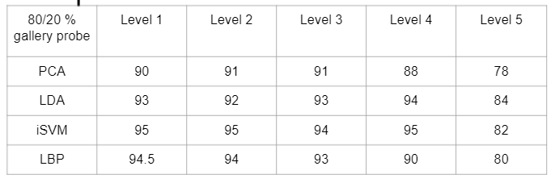

**6. A Real-time Face Recognition System Based on the Improved LBPH Algorithm**

     XueMei Zhao, Cheng Bing Wei* School of Electronic Information

     The recognition rate of the local binary pattern histogram (LBPH) algorithm can be reduced under illumination, expression change and attitude deflection. To solve this problem, a LBPH algorithm based on neighbourhood Gray median (MLBPH) is proposed. Use the median of the neighbourhood sampling values instead of intermediate values, thereby reducing the effects of extraction conditions on the characteristic value of illumination.

Read images with different expressions, read 500 frames at a time, repeat 10 times, and take the average.

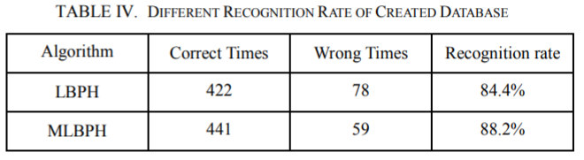

* 1. **Limitations of existing systems**
* Poor Image Quality Limits Facial Recognition Effectiveness
* Small Image Sizes Make Facial Recognition More Difficult.
* Different Face Angles Can Throw Off Facial Recognition Reliability.
* Data Processing and Storage Can Limit Facial Recognition Tech.

**2.3 Problem Statement**

Up to this date, there have been many face recognition systems. Our aim is to understand the working and efficiency of various algorithms used for the process and to compare and find the most accurate and efficient algorithm. We also aim to make a system that can be trained and can detect personalities by their images.

**2.4 Scope**

The facial recognition algorithms come in various architectures and flavours. We selected algorithms to test using the following criteria: Most used algorithms in the commercial sector, the popularity of the algorithms and with open-source availability. We did a case study involving these algorithms, involving developing a test application and collecting a novel dataset.

**Chapter 3 Project Proposal**

The drawbacks of the existing systems are needed to be solved and for this, we proposed this system with Face Recognition using Local Binary Patterns histogram (LBPH) to detect and recognize faces.

* 1. **Proposed Work**

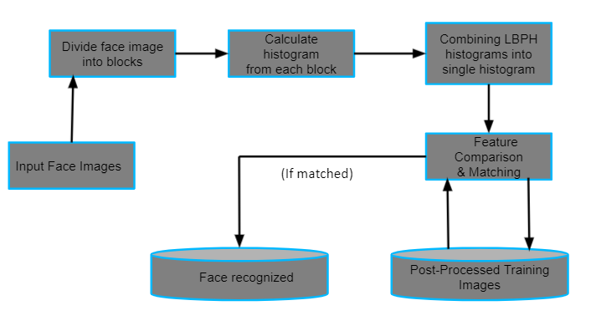

**Fig (A)**

* 1. **Proposed Methodology**

**Algorithm 1** LBPH Algorithm

* + 1. **LBPH Algorithm**

**Local Binary Pattern**(LBP) is a simple yet very efficient texture operator which labels the pixels of an image by thresholding the neighbourhood of each pixel and considers the result as a binary number*.* It was first described in 1994 (LBP) and has since been found to be a powerful feature for texture classification. It has further been determined that when LBP is combined with histograms of oriented gradients (HOG) descriptor, it improves the detection performance considerably on some datasets. Using the LBP combined with histograms we can represent the face images with a simple data vector.

1. **Parameters**: the LBPH uses 4 parameters:

* **Radius**: the radius is used to build the circular local binary pattern and represents the radius around the central pixel. It is usually set to 1.
* **Neighbors**: the number of sample points to build the circular local binary pattern. Keep in mind: the more sample points you include, the higher the computational cost. It is usually set to 8.
* **Grid X**: the number of cells in the horizontal direction. The more cells, the finer the grid, the higher the dimensionality of the resulting feature vector. It is usually set to 8.
* **Grid Y**: the number of cells in the vertical direction. The more cells, the finer the grid, the higher the dimensionality of the resulting feature vector. It is usually set to 8.

1. **Training the Algorithm**: First, we need to train the algorithm. To do so, we need to use a dataset with the facial images of the people we want to recognize. We need to also set an ID (it may be a number or the name of the person) for each image, so the algorithm will use this information to recognize an input image and give you an output. Images of the same person must have the same ID. With the training set already constructed, let’s see the LBPH computational steps.

**3. Applying the LBP operation**: The first computational step of the LBPH is to create an intermediate image that describes the original image in a better way, by highlighting the facial characteristics. To do so, the algorithm uses a concept of a sliding window, based on the parameter’s **radius** and **neighbours**.

The image below shows this procedure:

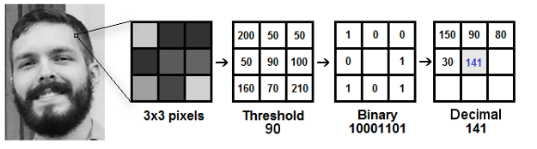**Fig (B)**

* 1. **Details of Hardware/Software Requirement**
     1. **Hardware Requirements: -**

Processor: Intel Core i3 processor Hard-disk: 128 GB

RAM: 4GB

### Software Requirements: -

Software:

* Computer vision 2 (OpenCV)
* Face recognition library for python
* NumPy library
* PyCharm IDE

**Chapter 4 Expected Results**

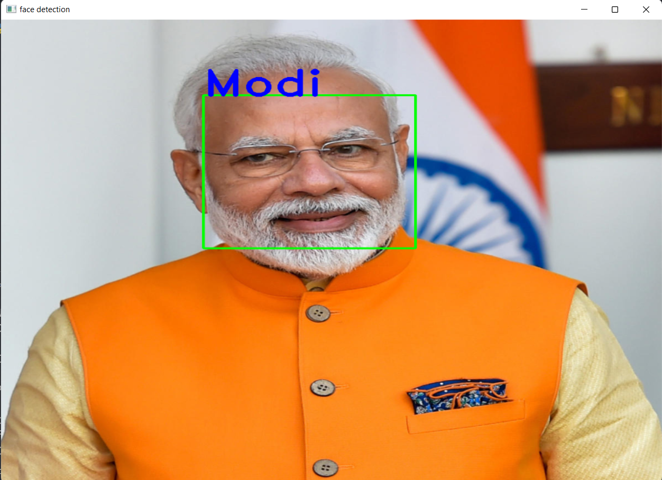

**Fig (B)**

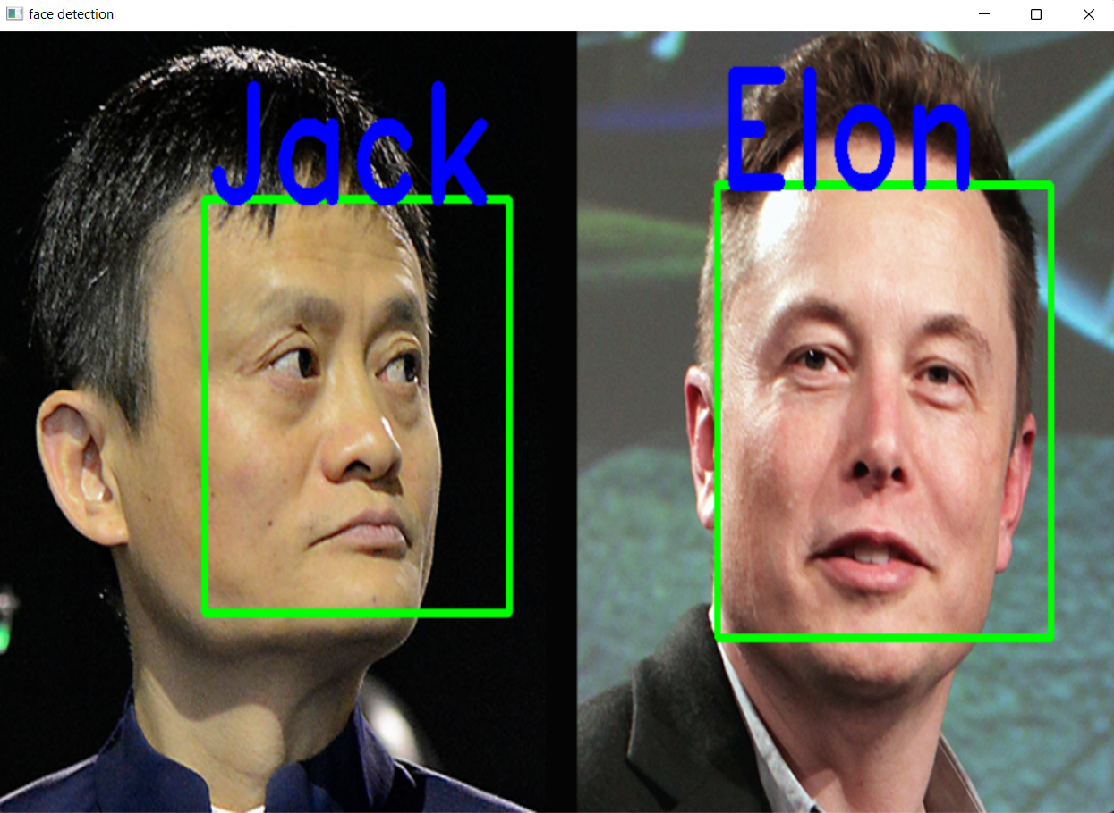

**Fig (C)**



**Fig (D)**

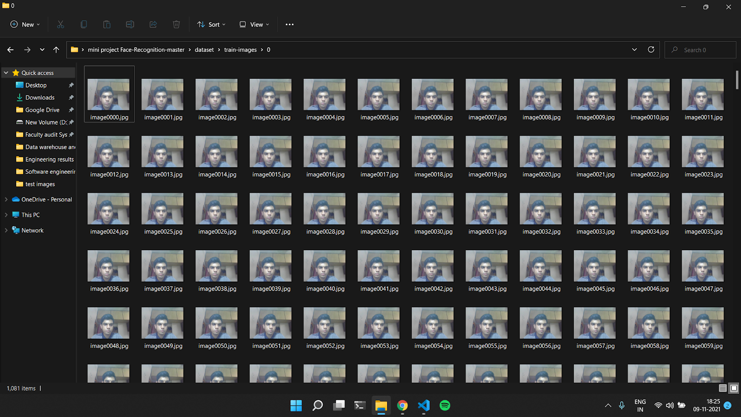

**Fig (E)**

**Chapter 5**

**Conclusion**

## Conclusion

* LBPH is one of the easiest face recognition algorithms.
* It is possible to get great results (mainly in a controlled environment).
* It is robust against monotonic Gray scale transformations.
* It is provided by the [OpenCV](https://opencv.org/) library (Open-Source Computer Vision Library).
* We observed that LBPH algorithm requires a large dataset to increase the accuracy of its face recognizer.

# References

1. https://ieeexplore.ieee.org/document/9215441
2. https://ijarcce.com/upload/2017/september-17/IJARCCE%2024.pdf
3. https://towardsdatascience.com/face-detection-with-haar-cascade-727f68dafd08
4. <https://www.analyticsvidhya.com/blog/2021/06/learn-how-to-implement-face-recognition-using-opencv-with-python/>
5. <https://towardsdatascience.com/building-a-face-recognizer-in-python-7fd6630c6340>
6. <https://becominghuman.ai/face-detection-using-opencv-with-haar-cascade-classifiers-941dbb25177>
7. Saliml Rhman, Rashidah Olanrewaju,Wasiu Adebayo Balogun. "Class attendance management system using face recognition." 2018 7th International Conference on Computer and Communication Engineering (ICCCE). IEEE, 2018.

# Acknowledgement

We take this opportunity to express our profound gratitude and deep regards to our guide **Mr. Tushar Ghorpade** sir for his exemplary guidance, monitoring and constant encouragement throughout the completion of this report. We are truly grateful to his efforts to improve our understanding towards various concepts and technical skills required in our project Face recognition System. The blessing, help and guidance given by him from time to time shall carry us a long way in the journey of life on which we are about to embark. We take this privilege to express our sincere thanks to **Dr. Mukesh D. Patil, Principal, RAIT** for providing the much necessary facilities. We are also thankful to **Dr. Leena Ragha, Head of Department of Computer Engineering**, **Project Coordinator** **Dr. Bharti ma’am**, Department of Computer Engineering, RAIT, Nerul Navi Mumbai for their generous support. Last but not the least we would also like to thank all those who have directly or indirectly helped us in completion of this project.